MYE -15 EXECUTION

TEST CASE: This test is to validate to open pop up window after clicking add activity button.

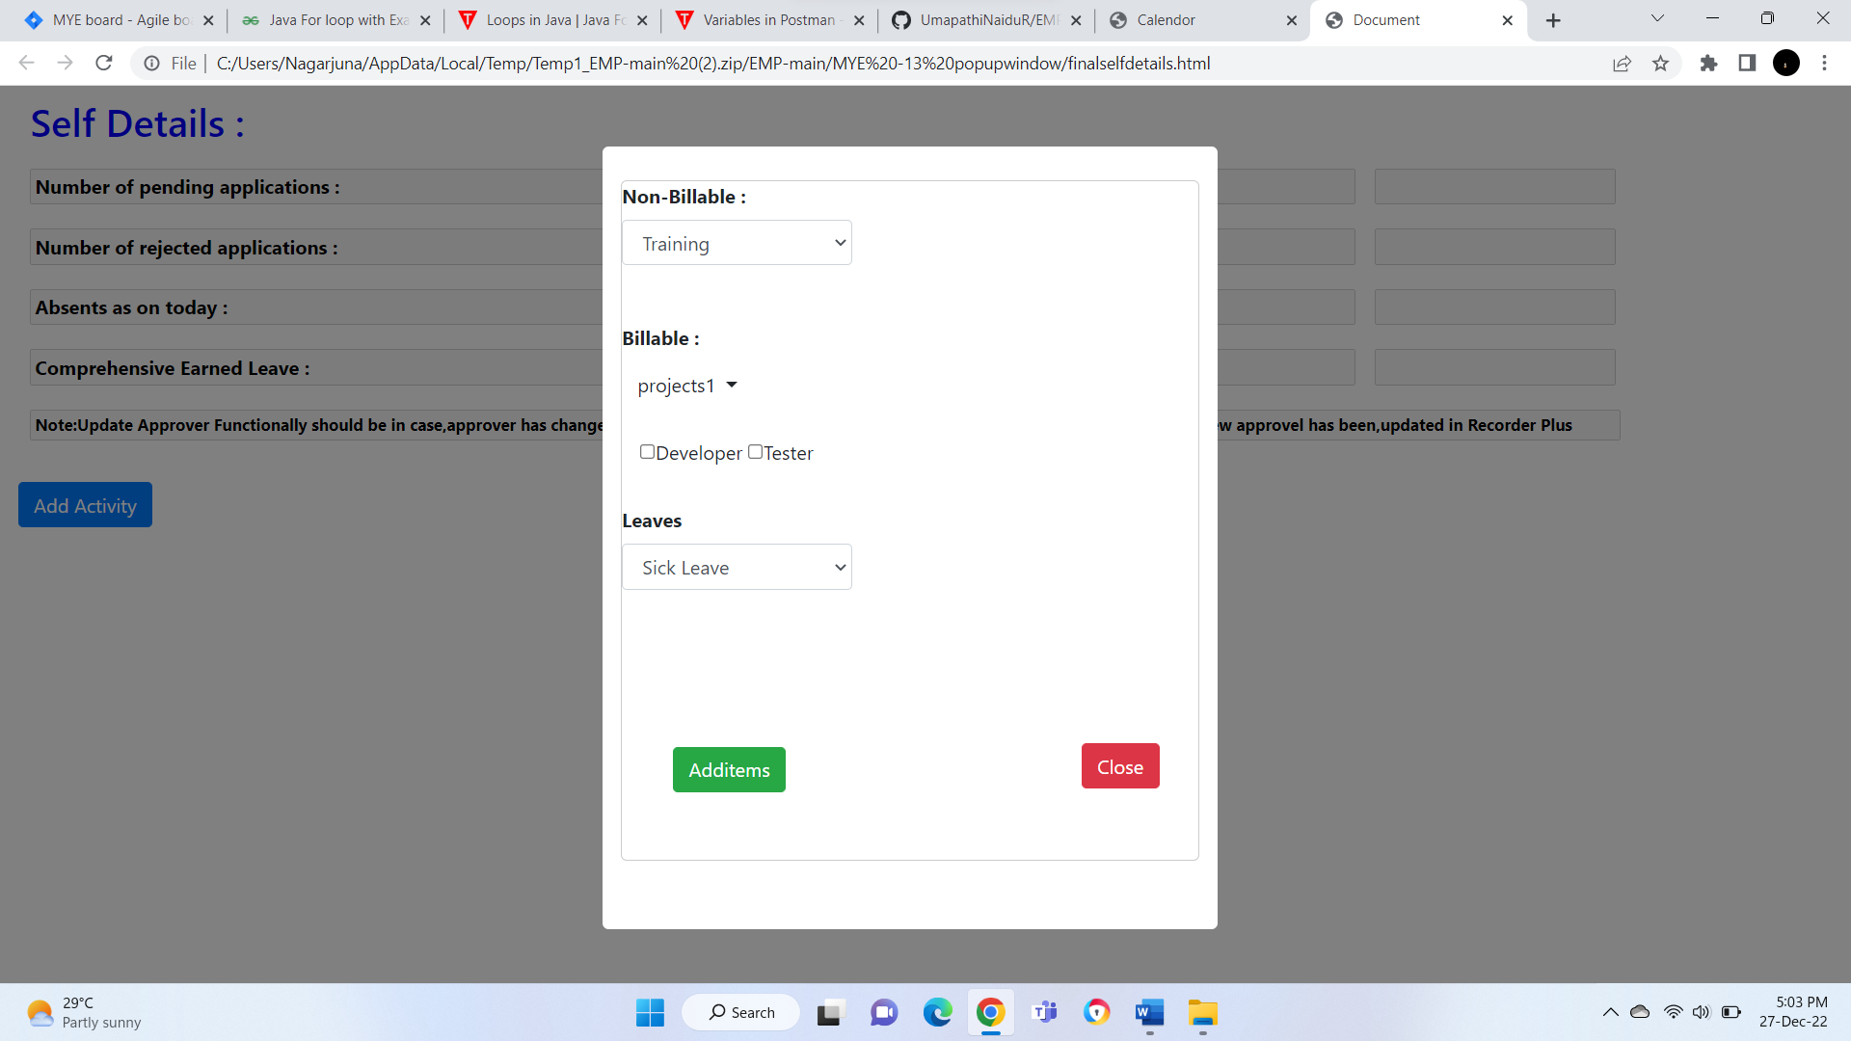

TEST CASE: this test is to validate the pop up window contains non billable drop down list

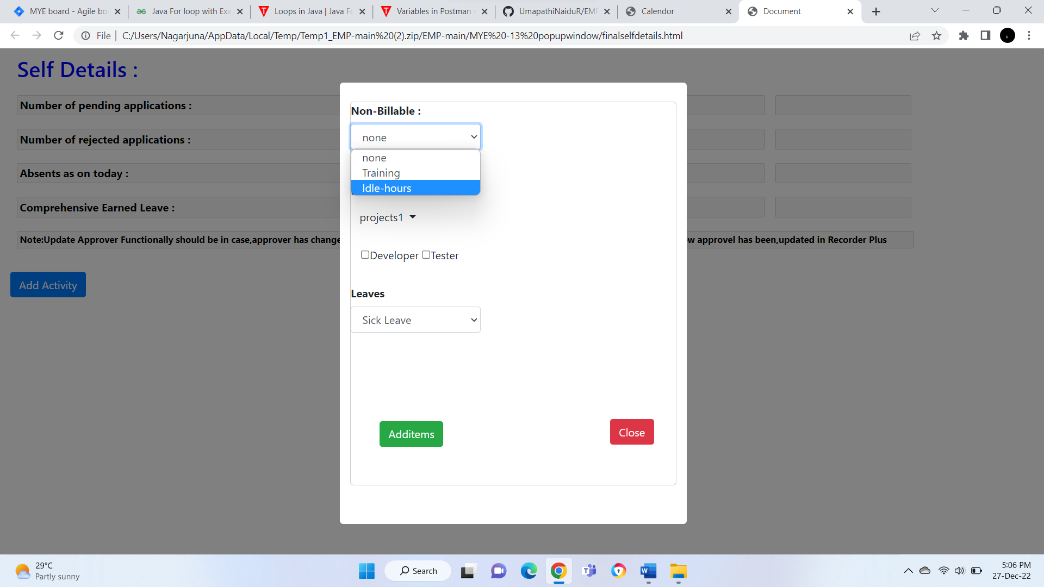

TEST CASE: this test is to validate the pop up window contains billable drop down list

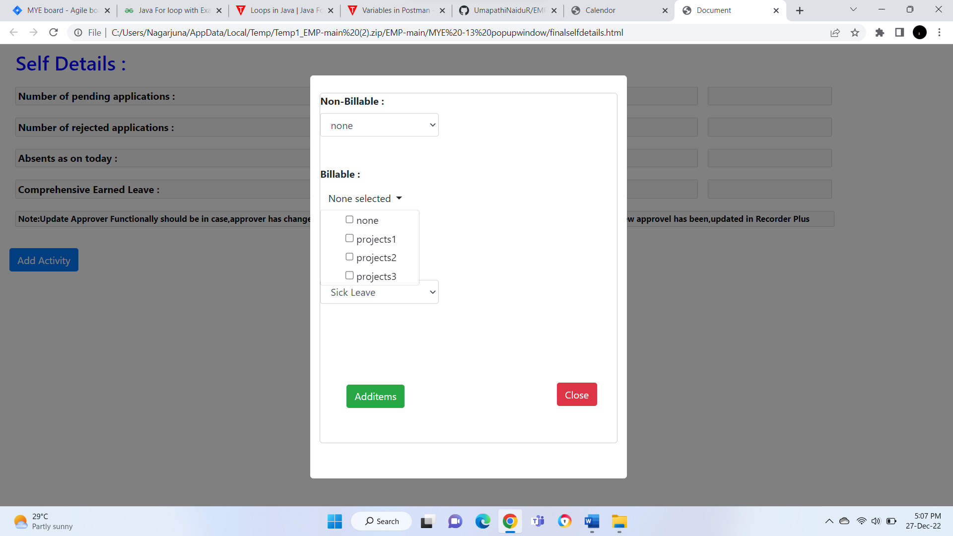

TEST CASE: this test is to validate the pop up window contains billable drop down list can select one project.

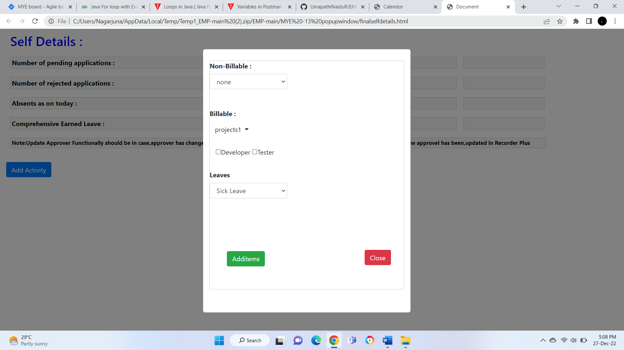

TEST CASE: this test is to validate the pop up window contains billable drop down list can select more than one project.

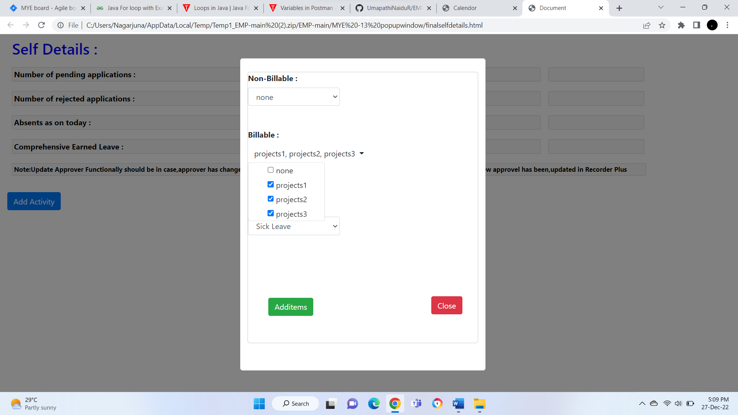

TEST CASE: this test is to validate the pop up window contains developer check boxes

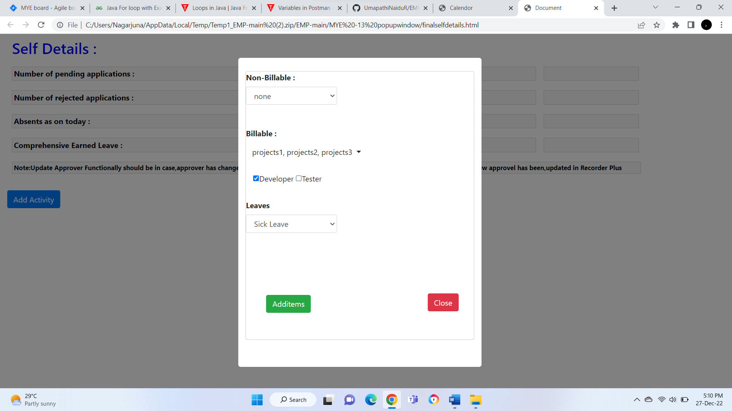

TEST CASE: this test is to validate the pop up window contains tester check boxes

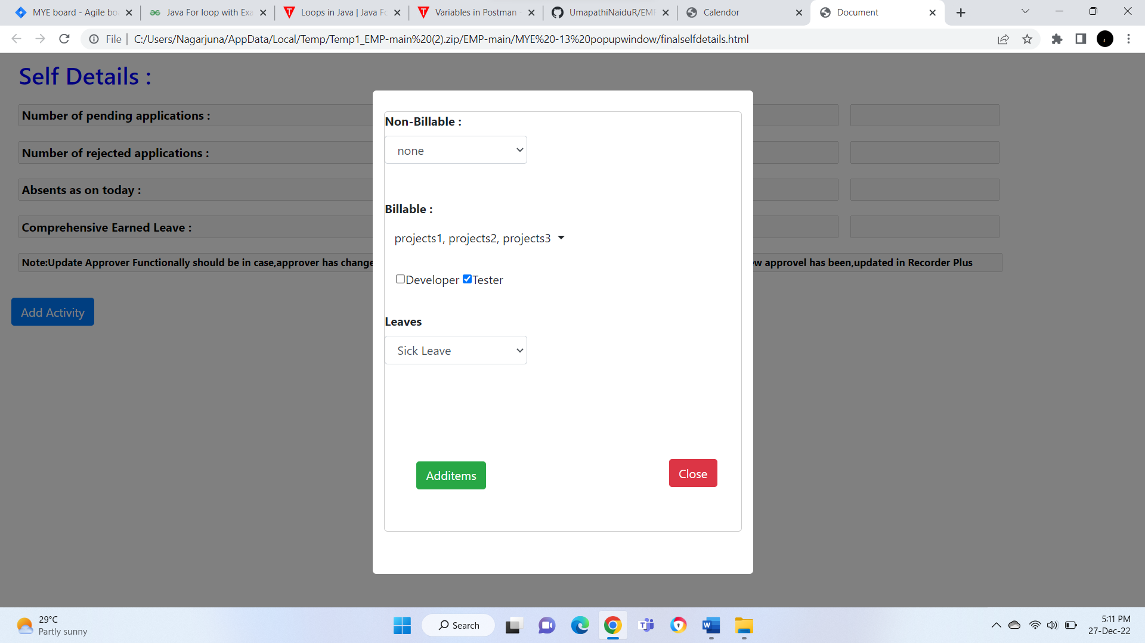

TEST CASE: this test is to validate the pop up window contains leaves drop box.

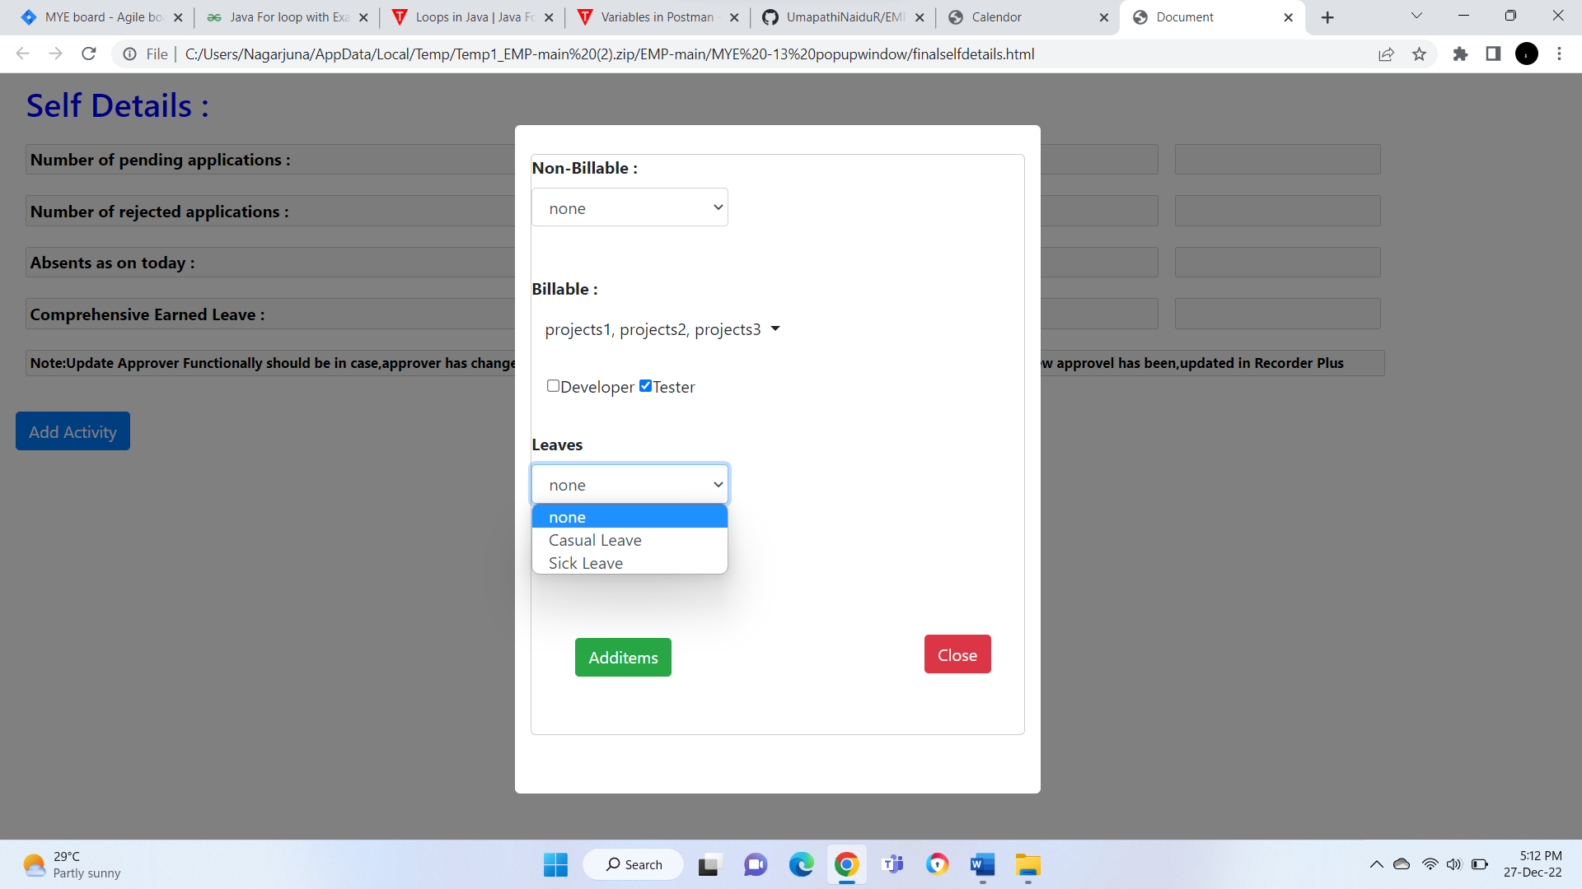

TEST CASE: this test is to validate the pop up window contains add items tab and clickable.

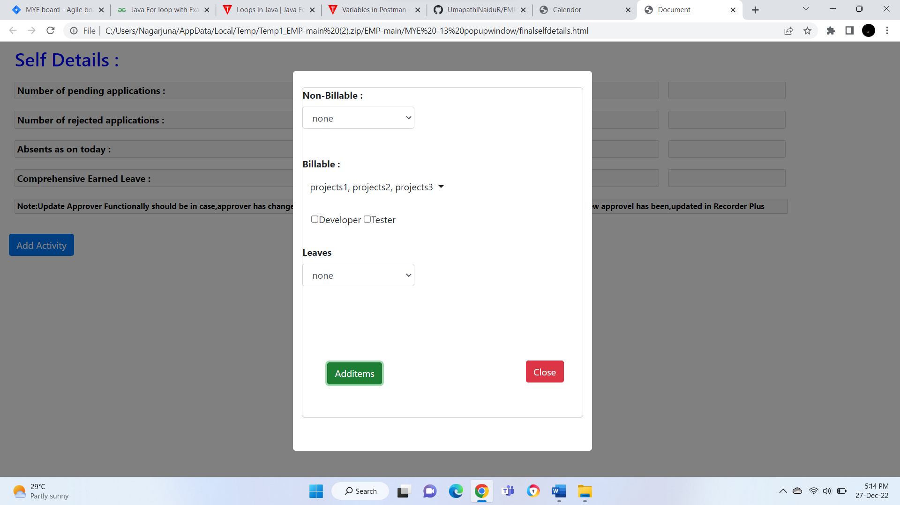

TEST CASE: this test is to validate the pop up window contains close tab and clickable.

